C2SIM Problem Report - Change Request (PR-CR)

Assigned PR-CR Identifier: PR2021-1

Submission Block
Submitter Name: Ole-martin Mevassvik
Submitter Organization: FFI
Submitter Contact Information (email): Ole-Martin.Mevassvik@ffi.no

Submitter Name: Geir Sletten
Submitter Organization: FFI
Submitter Contact Information (email): geir.sletten@ffi.no

Type (Problem Report or Change Request): Problem Report
Date of Submission: 27 January 2021
Product: C2SIM_SMX_LOX_v1.0.0 XML Schema generated from C2SIM 1.0.0 + SMX + LOX ontology (rdf/xml)
Problem/Change Description:
FFI and Hyssos Inc. has for some time worked together to create an experimental system for simulation supported wargaming for the land operations planning process. This is by combining Sketch-thru-Plan, which creates a digital army Course of Action (COA), and SWAP, that is capable of capturing and simulating a COA.
We have for some time looked at how we can use the current C2SIM standard, more precisely LOX, for the interface between STP and SWAP. In this work we have discovered some issues related to control features/task graphics that we would kindly ask the PSG to clarify.
To be more precise, we need to add control features like boundary lines, phase lines, objective areas etc. to one or more maneuver warfare tasks. Looking at the schema, this could be done by defining entities under <ObjectDefinitions> in the current schema. There are two issues with this. One is that we are only able to create a <MapGraphic> object, which is a subelement of <PhysicalEntity>. Looking at the ontology, the control features mentioned above do not satisfy the definition of a physical entity.
In our case the TaskGraphic (or TacticalGraphic) element seems to be a better choice compared to MapGraphic as it adds semantical information. From the definition, the TaskGraphic element has the same subelements as MapGraphic except that it adds an owner element. Logically the MapGraphic and TaskGraphic elements should be interchangeable (in the ontology TaskGraphic is a subclass of MapGraphic). There is however no way of defining a TaskGraphic element in the current schema.
To summarize:
- Would it be correct to refer to a TaskGraphic element in the MapGraphicID reference in ManeuverWarfareTask?
- How can we create a TaskGraphic element within the current schema?

Using ontology subclasses of MapGraphic in XML
When representing tasks in a Norwegian scenario, we also want to represent a number of control measures. Following the structure in Protégé, we find the following:
Entity
hasEntityType:EntityType
hasName:string
hasUUID:UUIDBase
PhysicalEntity
hasCurrentState:PhysicalState
hasMarking:string
MapGraphic
TacticalGraphic
TaskGraphic
hasOwner:UUIDBase
However, when using XMLSpy to write XML code, we cannot find a path to the subclasses of MapGraphic. An extract of our XML code is shown below:
<Entity>
<PhysicalEntity>
<MapGraphic>
<EntityType>
<APP6-SIDC>
<SIDCString>G-FPLN----**--X</SIDCString>
</APP6-SIDC>
</EntityType>
<Name>Line</Name>
<UUID>a938b651-1c04-a649-d192-b13006022521</UUID>
<CurrentState>
<PhysicalState>
<Location>
<GeodeticCoordinate>
<AltitudeAGL>0.0</AltitudeAGL>
<Latitude>59.790195</Latitude>
<Longitude>11.431973</Longitude>
</GeodeticCoordinate>
</PhysicalState>
</CurrentState>
</MapGraphic>
</PhysicalEntity>
</Entity>
We have not found a way to represent the subclasses below MapGraphic. In the XML schema (C2SIM_SMX_LOX_v1.0.0), we can find TacticalGraphic, with all expected further subclasses from the ontology shown as an element. We can also find MapGraphic as an element, but we cannot find a link to the expected subclass TacticalGraphic. So far, we have not found any other paths in XMLSpy (or the schema) to use TacticalGraphic either. Pictures from XMLSpy are shown below.
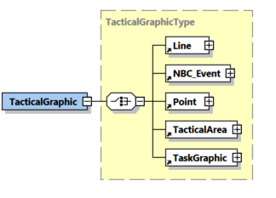
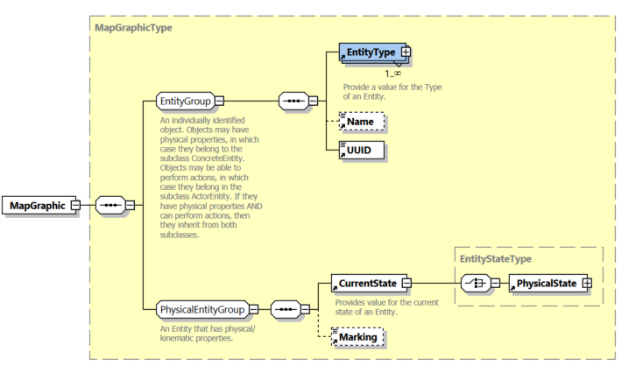
How can we create XML code with this link? Currently, the only way to tell if a MapGraphic is a Line or Point etc. is by the APP6 symbol code (besides giving it a textual name).

Analysis Block
Date Assigned for Analysis: 27 January 2021
Assigned Analyst Name: Doug Reece
Analyst Organization: MAK Technologies, Inc.
Analyst Contact Information (email): dreece@mak.com

Date of Analysis: 28 January 2021
Problem/Change Analysis:
I looked at the xsd file which I believe is the latest, and also at the LOX v1.0.0 ontology file, to try to figure out what is going on.
The class PhysicalEntity in the ontology has 4 subclasses: CulturalFeature, EnvironmentalObject, GeographicFeature, and MapGraphic. Unfortunately, none of these subclasses has any additional properties to distinguish them from PhysicalEntity or from each other. (Probably what they should have is, at least, restrictions on the range of values that they can have in their hasEntityType properties.)
As a result, the subclass type definitions include only the references to the groups of elements they inherit, i.e. PhysicalEntityGroup and EntityGroup.
However, the MapGraphic actually has subclasses itself--METOCGraphic and TacticalGraphic. TacticalGraphic has the property (not found in MapGraphic) hasOwner. It also has additional subclasses. What I think we want in the xsd file is for MapGraphicType to have a choice node for its subclasses. (TacticalGraphic does have a choice node for its subclasses.) I suspect that the lack of properties in MapGraphic caused the xslt translation to fail to do what we want.
Is this what you would expect the xslt to do? To fix this, is a fix to the xslt needed, or is the right thing to do to fix the ontology?
Additional Comments 22 February 2021:
After the discussions about the ontology surrounding the SIW paper, I have been wondering if we should do a revision of the ontology to correct some of the definitions it is lacking. In particular,
- there are a number of subclasses that don't have additional restrictions to differentiate them from their parents.
- we need to find a way to express an axiom that says that if a parent class has two optional properties, at least one of them is required
- we need to find a better way to describe a class like Maneuver Warfare Task that inherits the restriction that it has a code, but chooses among a different set of code values than its parent Task.
- we maybe should look at including "short cuts", e.g. to give physical entities hasLatitude etc. data properties, to avoid having to include several levels of sub-types in the xml.
Most of this could be done with extensions I think, but on the other hand they are fixes so maybe should be changes.

Date Re-assigned for Analysis: 28 January 2021
Assigned Analyst Name: Curtis Blais
Analyst Organization: Naval Postgraduate School
Analyst Contact Information (email): clblais@nps.edu

Date of Analysis: 7 March 2021
Problem/Change Analysis:
An expedient fix is to modify manually the C2SIM_SMX_LOX_v1.0.0 XML Schema to add the needed substructure:
<xs:complexType name="MapGraphicType">
<xs:annotation>
<xs:documentation>Graphics on a map that define locations, lines, areas, actions, etc. The location of the graphic is the location in the real world represented on the map. The extent is the set of handle points or vertices that define its shape and size. This class includes task graphics, METOC graphics, and MOOTW graphics.</xs:documentation>
<xs:documentation>http://www.sisostds.org/ontologies/C2SIM#MapGraphic</xs:documentation>
</xs:annotation>
<xs:choice>
<xs:element ref="METOCGraphic"/>
<xs:element ref="TacticalGraphic"/>
<xs:element ref="UnitSymbol"/>
</xs:choice>
<!-- inserted for PRCR-2021-1 -->
<!-- inserted for PRCR-2021-1 -->
<!-- removed for PRCR-2021-1
<xs:sequence>
<xs:group ref="EntityGroup"/>
<xs:group ref="PhysicalEntityGroup"/>
<xs:choice>
<xs:element ref="METOCGraphic"/>
<xs:element ref="TacticalGraphic"/>
<xs:element ref="UnitSymbol"/>
</xs:choice>
</xs:sequence>
removed for PRCR-2021-1 -->
</xs:complexType>
<xs:element name="MapGraphic" type="MapGraphicType"/>
<!-- added for PRCR-2021-1 -->
<xs:element name="METOCGraphic">
<xs:complexType>
<xs:sequence>
<xs:group ref="EntityGroup"/>
<xs:group ref="PhysicalEntityGroup"/>
</xs:sequence>
</xs:complexType>
</xs:element>
<!-- added for PRCR-2021-1 -->

Of course, this does not solve the problem of what is generated in the XML schema document for the combined C2SIM+SMX+LOX ontology by the XSLT. Simply changing the XSLT to produce this does not address the more important question of why the ontology has subclasses that are not differentiated from the respective parent classes or other sibling classes.

Sent the following message (with modified XML Schema document as an attachment) to the originators on 7 March 2021 requesting their feedback:
In the attached version of the C2SIM-SMX-LOX schema, I have made some changes manually to the XML schema document to help me think about what the XSLT is going to have to do to generate a workable schema. Please take a look at the MapGraphic structure and see if that is what you had in mind, or let me know if I have missed the mark in some way. Once I have a good handle on what we think the schema should enable us to do, I can dig deeper into the XSLT code to generate the desired XML schema structures, although the better solution may be to refine some of our class definitions (e.g., we have subclasses of PhysicalEntity that do not have any distinguishing characteristics, and this is compounded by a similar consideration with subclasses of MapGraphic).

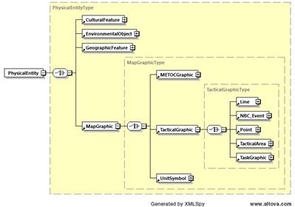

Additional Correspondence:
March 9, from Magdalena:
Michael and I are currently working on an extension for a project and are discussing limitations of the transformation.
Michael is very interested in the transformation process and would like to be involved exploring some possibilities to use even more information from the ontology in the schema.

March 9, from Bruno:
Yes, it looks similar to one of the issues that Magdalena and I have found, during the design of the Tactical DataLink extension (TDL).
In the TDL extension, we have created the following class hierarchy in the ontology (new elements in bold):
- Action
- Task
- TDLTask
- TDLFlightPlanTask
- hasTDLLocationAndTime some TDLLocationAndTime
- ...
- TDLMissionTask...
- hasDateTime max 1 DateTime
- ...

In our first version of the extension, the “TDLTask” class had no property restriction (because all the common properties were already inherited from the “Task” class, and because all sub-classes have a distinct property set).
But after a few tries with the schema generation, the property restriction “hasDummyProperty” has been added to the “TDLTask”. Without that "dummy" property, the generated schema didn't contain the sub-choices for the sub-classes of the “TDLTask”.
I think it's the same issue that Ole-Martin reported, because MapGraphic class do not contain property restriction.
There is an easy workaround : add a dummy property to the MapGraphic class…. but it would be better if someone could "fix" the XSLT for that ;)

March 10, from Curt:
Yes, we get the same result with your example. I will work on catching that special case in the XSLT. The reported problem situation is even worse, in that the class hierarchy for that problem has unspecialized subclasses at different levels of the hierarchy, so the XSLT even creates some duplicate structures in the XML schema generated from the inherited properties.
The ontology design raises some questions, though, about what we mean from the ontology perspective. For example, rather than having the unspecialized subclass TDLTask of class Task, we could remove that layer and just have TDLFlightPlanTask and TDLMissionTask be direct subclasses of Task. That would generate the schema structures we want without the added layer of element structure in the XML schema. Or, maybe we end up declaring TDLFlightPlanTask and TDLMissionTask as disjoint and define the TDLTask subclass as the union of those subclasses (and then add logic to the XSLT to make the XML schema structure for TDLTask be a choice of the TDLFlightPlanTask or TDLMissionTask elements).
If we want to have a partitioning of subclasses of Task, then perhaps we should determine what makes a TDLTask different from, say, an AutonomousSystemTask. Maybe it is based on the kind of entity performing the task or something. It could be that we just do not have sufficient detail in the ontology design yet to enable us to differentiate these subclasses in a natural way.
So, this is an interesting problem that will keep us busy for a while deciding on a good approach. Adding the logic to the XSLT can give us a workable solution for now, but might mask a more important issue that will be discovered when the reasoner infers that many classes we thought were different in some way are actually describing the same set of members.

Resolution Block
Implementer Name (if different from Analyst): Bruno Gautreau
Implementer Organization: AirBus
Implementer Contact Information (email): bruno.gautreau@airbus.com

Date of Resolution: 12 August 2021
Specific Correction or Change Implemented:
Modified the XSLT to generate an XML Schema choice structure for subclasses defined in the C2SIM ontology.
Please find here a proposed complete correction with the following files of the attached zip file:
- C2SIMOntologyToC2SIMSchemaV1.0.0-new.xslt : the modified XSLT
- C2SIMOntologyToC2SIMSchemaV1.0.0.xslt : the original XSLT file (to easily make the diff with the new one, in case I didn’t get the new one)
- C2SIM_SMX_LOX_merged-new.xsd : the XSD that is generated on my platform from C2SIMOntologyToC2SIMSchemaV1.0.0-new.xslt
- C2SIM_SMX_LOX_merged.xsd : the XSD that is generated on my platform from C2SIMOntologyToC2SIMSchemaV1.0.0.xslt
The differences between C2SIM_SMX_LOX_merged.xsd and C2SIM_SMX_LOX_merged-new.xsd show that:
- new xs:annotation for the complexType ending by ‘Type’
- MapGraphicType is now generated with
<xs:choice>
<xs:element ref="METOCGraphic"/>
<xs:element ref="TacticalGraphic"/>
<xs:element ref="UnitSymbol"/>
</xs:choice>
- MilitaryOrganizationType is now generated with
<xs:choice>
<xs:element ref="Unit"/>
</xs:choice>
- LineType is now generated with
<xs:choice>
<xs:element ref="Boundary"/>
<xs:element ref="Route"/>
</xs:choice>
- And the following declarations are also generated
<xs:complexType name="METOCGraphicType">
<xs:sequence>
<xs:group ref="PhysicalEntityGroup"/>
<xs:group ref="EntityGroup"/>
</xs:sequence>
</xs:complexType>
<xs:element name="METOCGraphic" type="METOCGraphicType"/>
<xs:complexType name="BoundaryType">
<xs:sequence>
<xs:group ref="TacticalGraphicGroup"/>
<xs:group ref="PhysicalEntityGroup"/>
<xs:group ref="EntityGroup"/>
</xs:sequence>
</xs:complexType>
<xs:element name="Boundary" type="BoundaryType"/>
<xs:complexType name="RouteType">
<xs:sequence>
<xs:group ref="TacticalGraphicGroup"/>
<xs:group ref="PhysicalEntityGroup"/>
<xs:group ref="EntityGroup"/>
</xs:sequence>
</xs:complexType>
<xs:element name="Route" type="RouteType"/>
And there's no more error in the generated XSD :)
The differences between C2SIM_SMX_LOX_merged.xsd and C2SIM_SMX_LOX_merged-new.xsd shows the following modifications:
- in template ComplexTypesFromClassStructures : modification of some code logic
- in template GenerateComplexType: modification of a condition
- in template CreateChoiceOfSubclasses : addition of comments in the generated complex type
NB: in this last template, I’ve also added another modification (min=0 on the 'xs:choice' element), to be able to create instances of a class that have subclasses. But I “removed” this modification by putting it within comments.

Additional Comments: Change tested by Ole-Martin Mevassvik and found acceptable, with addition of alphabetization of subelements in XML complex types. This is a separate Java program, posted to the C2SIM github site, run against the generated XML schema.

C2SIM files are managed in the C2SIM github site: https://openC2SIM.github.io

C2SIM products relating to resolution of this Problem Report / Change Request are posted to the SISO Digital Library under Development Groups / C2SIM PDG PSG / _C2SIM PDG Products / Ontologies.

